Sustainable Family Communities Webpage Start-Up Guide

**Pushing the Files to the Server**

1. You will receive a folder that holds all of the files that need to be stored on the server to be able to render the page correctly.
   1. DO NOT CHANGE THE NAMES OF THE FILES WITHIN THE FOLDER!
   2. You can change the name of the folder itself without consequence.
      1. The name of the folder that holds the files will be the name of the directory in which the files are stored on the server, once you transfer them up. So shortening the name of the folder will create for a shorter directory name.
      2. Ex. www.website.org/shortname

or

www.website.org/verylongdirectoryname

1. Using a File Transfer Client (such as FileZilla), transfer the files from your local machine to your specified directory on the server.
2. You should now be able to view the webpage by entering the file path that leads to the directory into the browser.

**Changing Videos**

1. Go to your YouTube.com account, and find the video that you would like to use inside the webpage.
2. Below the video, click the share button (Circled in red on the below image).
   1. 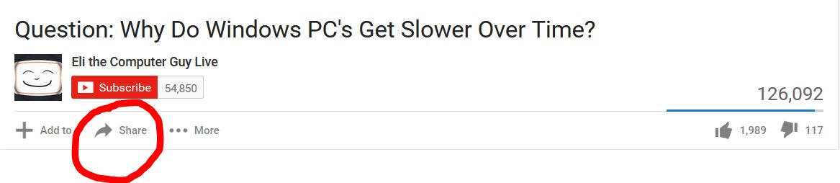
3. Another box will pop up. On that box, click the embed button (Circled in red on the below image).
   1. 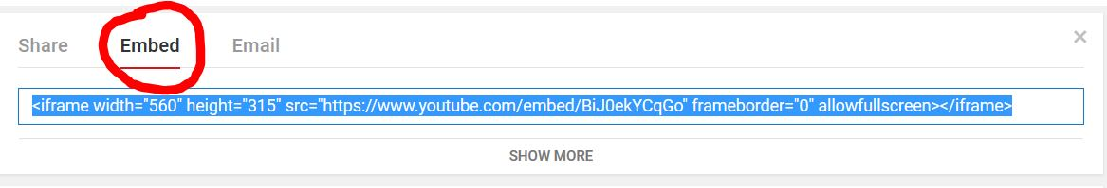
4. Then copy the ID for that video (Underlined in Teal on the below image). This ID will be different for every video. Do not copy the quotation mark to the right, nor the forward slash to the left. Just copy the Alpha-numeric id (there will be characters mixed in there sometimes…nothing to worry about).
   1. 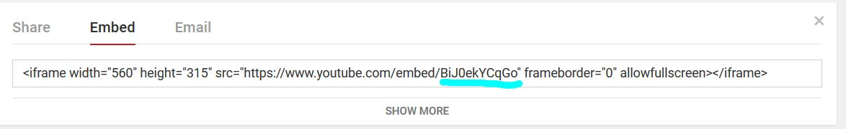
5. Now you can paste that ID somewhere, or just remember that you have it copied, so don’t copy anything else for the next few steps.
6. Open the index.html file using some sort of simple text editor.
   1. I recommend either Notepad++ or Sublime Text….Both are free to download and use.
   2. You can also use the standard notepad that comes with every window computer, or similar text editors on other operating systems.
      1. These are perfectly fine to use, just a little boring to look at and they don’t highlight syntax (keywords).
7. Once you have the file open, this is what you will see, more or less (Image Below). The video IDs are underlined in teal, and their corresponding button is underlined in red. The video closest to the top is the video that plays when the webpage is loaded, the rest are linked to the buttons.

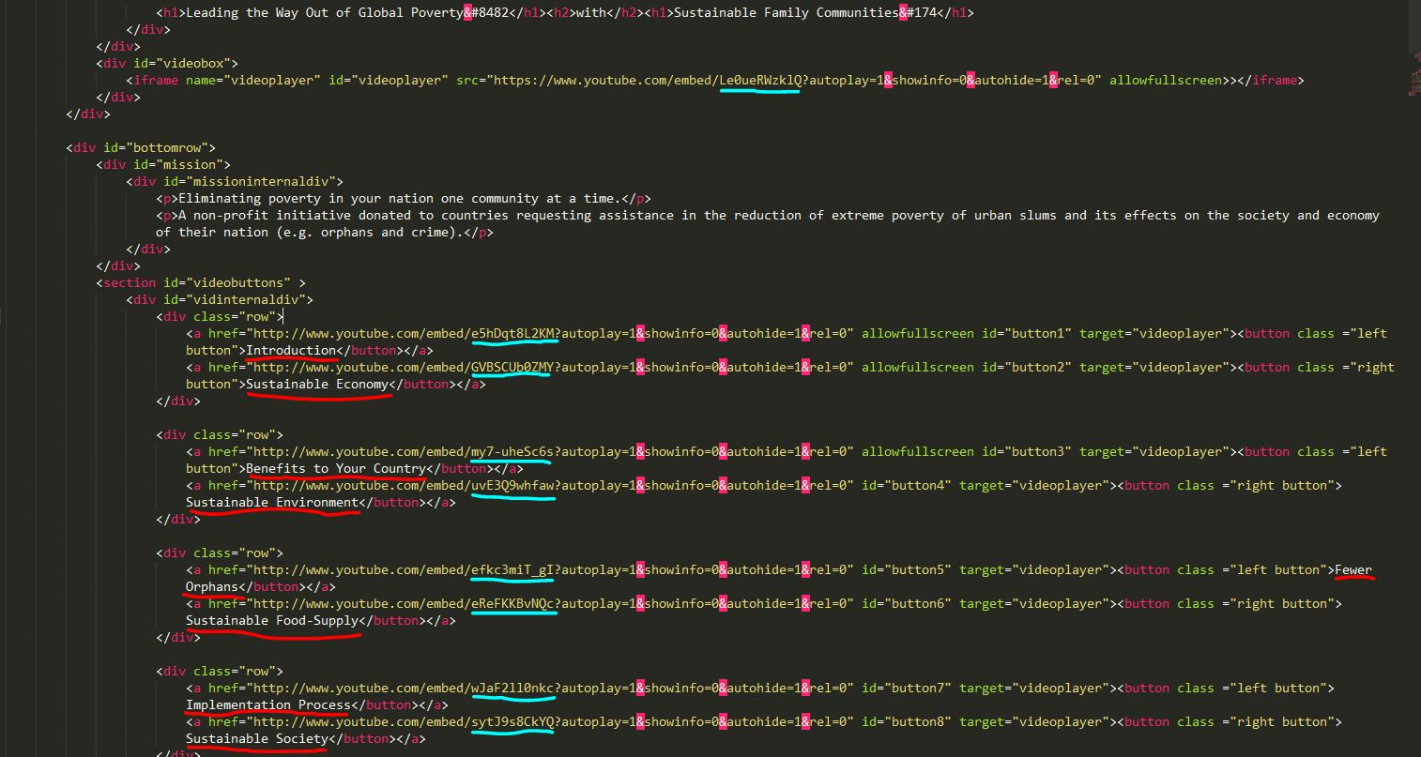

1. In the index.html file, highlight the Video ID (Underlined in teal) for the video that you want to replace. You should only be highlighting between the “/” and “?”.
2. Once you have the correct video ID highlighted, paste in the video ID that you copied earlier.
3. That’s it! Make sure that you **save your changes!!!!**
4. Repeat the above steps for each video that you want to replace.
5. **DO NOT ALTER ANYTHING ELSE IN THE CODE!!**
   1. Remember, if you accidently delete something or make a mistake, you can press ctrl+z to undo recent changes.

It was an honor to be able to work with your organization!! Hopefully my contribution will prove fruitful for you guys. Best of luck in the future!!